Sign in Page-

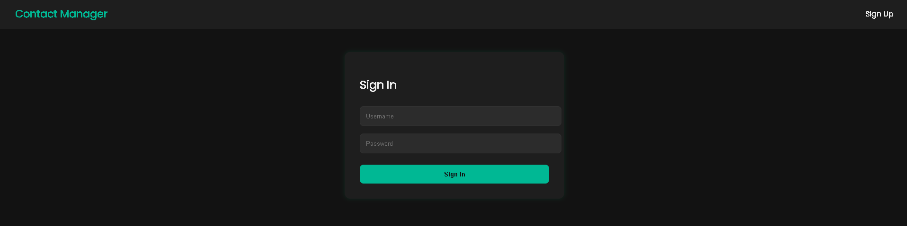

Sign up page-

Add Contact-

Postman requests:

Create contact:

Get all contacts:

Update :

Delete:

Database:

